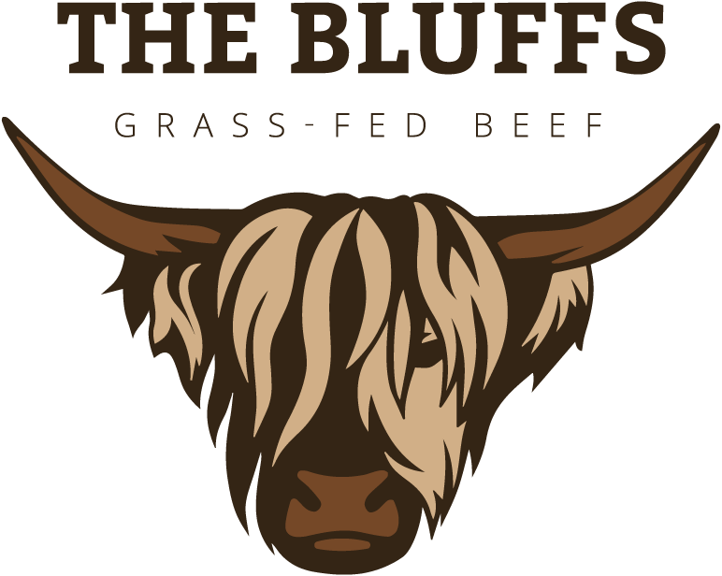
Order Form
Grass-Fed Beef ∙ Pastured Pork ∙ Pastured Lamb ∙ Free-Range Eggs
320.333.5498 ∙ ashley@thebluffsbeef.com ∙ @thebluffsbeef

Your Name:
Preferred Method of Contact:
Pick-Up or Delivery Location:

Using this form: Enter the number of packages of items you wish to pre-order (note that ribeyes, NY strips, and tenderloin steaks come in packages of two). Let us know your preferred location for pick-up (at the farm, or at the Melrose, Waite Park, or Buffalo Farmers Markets) or delivery (note that a delivery fee may apply). Email your order to ashley@thebluffsbeef.com We will send you a finalized invoice based on package weights and available inventory when your order is ready.

Quantity | GRASS-FED BEEF | Price | Quantity | GRASS-FED BEEF | Price
 | Ground < 5 lbs | $7.50/lb |  | Hamburger Patties | $8.00/lb
 | Ground ≥ 5lbs | $7.00/lb |  | Pepper Sticks | $12.00/lb
 | Steaks |  |  | Cheddar Sticks | $12.00/lb
 | Ribeye | $19.00/lb |  | Honey BBQ Sticks | $12.00/lb
 | New York Strip | $17.00/lb |  | Hot Dogs | $12.00/pkg
 | Sirloin | $14.00/lb |  | Summer Sausage | $10.00/lb
 | Tenderloin | $20.00/lb |  | Organ Meats
 | Flank | $13.00/lb |  | Heart | $5.00/lb
 | Skirt | $13.00/lb |  | Liver | $5.00/lb
 | Hanger | $13.00/lb |  | Oxtail | $5.00/lb
 | Roasts |  |  | Tongue | $5.00/lb
 | Chuck | $9.00/lb |  | Liver Dog Treats | $6.00/pkg
 | Arm | $9.00/lb | Quantity | POULTRY ITEMS | Price
 | Sirloin Tip | $9.00/lb |  | Whole Chicken | $5.00/lb
 | Rump | $9.00/lb |  | 8-Piece Chicken | $7.00/lb
 | Brisket | $10.00/lb |  | Free-Range Eggs | $5/dozen
 | Short Ribs | $7.25/lb | Quantity | STEAKHOLDERS CLUB
 | Stew Meat | $10.00/lb |  | Membership | $75
 | Soup Bones | $5.00/lb
Quantity | BULK PACKAGES |  | Quantity | WHOLE, HALVES, AND QUARTERS
 | Sample Package | $160/pack |  | Quarter Beef | $6.50/lb
 | Grill Package | $160/pack |  | Half Beef | $6.00/lb
Quantity | SPECIALTY ITEMS | Price |  | Whole Beef | $5.75/lb
 | Insulated Tote | $5/bag
 | Skull with Horns | $600 |  | Half Lamb | $5.25/lb
 | Custom Skull | $1000 |  | Whole Lamb | $5.00/lb
 | 100% Tallow Soap | $3/bar
 | Specialty Soap | $6/bar | Sold Out | Half Pork | $5.00/lb
 | Tallow Balm | $8/jar | Sold Out | Whole Pork | $4.45/lb

